**Project Design Phase-II**

**Technology Stack (Architecture & Stack)**

|  |  |
| --- | --- |
| Date | 31 January 3035 |
| Team ID | LTVIP2025TMID47516 |
| Project Name | iRevolution: A Data-driven Exploration of Apple's iPhone Impact in India using Tableau |
| Maximum Marks | 4 Marks |

**Technical Architecture:**

The Deliverable shall include the architectural diagram as below and the information as per the table1 & table 2

**Example: Order processing during pandemics for offline mode**

**Reference:** [**https://developer.ibm.com/patterns/ai-powered-backend-system-for-order-processing-during-pandemics/**](https://developer.ibm.com/patterns/ai-powered-backend-system-for-order-processing-during-pandemics/)

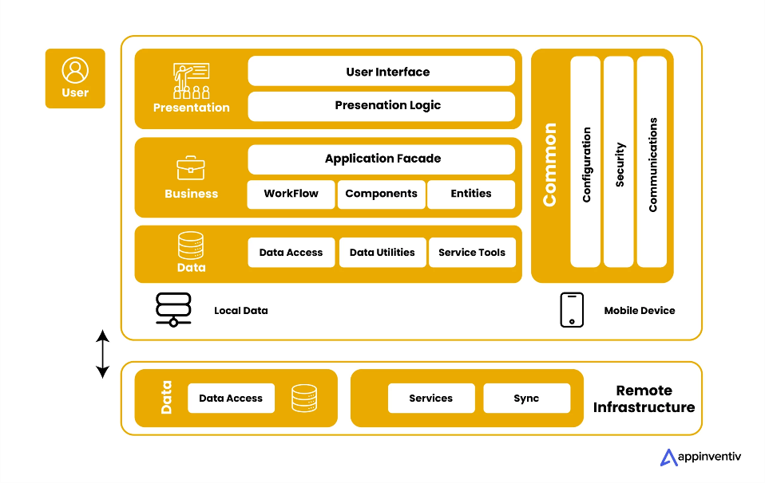

**Table-1 : Components & Technologies:**

|  |  |  |  |
| --- | --- | --- | --- |
| S.No | Component | Description | Technology |
| 1 | User Interface | How user interacts with the application (Web dashboard) | HTML, CSS, Flask (Jinja2) |
| 2 | Application Logic-1 | Data Preprocessing & Analysis | Python (Pandas, NLTK) |
| 3 | Application Logic-2 | Sentiment Analysis of social media data | TextBlob / VADER (Python) |
| 4 | Application Logic-3 | Visualization rendering and filter logic | Tableau |
| 5 | Database | Structured sales/demographic/social media data | SQL (DB2 Local) |
| 6 | Cloud Database | Remote access & scalability of data storage | IBM DB2 on Cloud |
| 7 | File Storage | Storage of reports and exports | Local Filesystem |
| 8 | External API-1 | Optional integration of real-time Twitter data | Twitter API |
| 9 | External API-2 | Optional use of news/sentiment APIs | News API, TextRazor |
| 10 | Machine Learning Model | Sentiment classification | TextBlob/VADER Sentiment Model |
| 11 | Infrastructure | App deployment and Tableau hosting | Flask (Localhost) + Tableau Public / Server |

**Table-2: Application Characteristics:**

|  |  |  |
| --- | --- | --- |
| S.No | Characteristics | Technology |
| 1 | Open-Source Frameworks | Flask, Pandas, NLTK, Tableau Public |
| 2 | Security Implementations | Role-based Flask routing, IAM controls on DB2, HTTPS |
| 3 | Scalable Architecture | 3-Tier Architecture: UI - Logic - DB |
| 4 | Availability | Hosted dashboards on Tableau Public / Flask with fallback URLs |
| 5 | Performance | Optimized SQL queries, Tableau extracts, local caching in Flask |